**EXPERIMENT 1**

**Aim :**

Introduction to Android Mobile Applications Development Tool.

**Theory :**

Android Studio is the official Integrated Development Environment (IDE) for Android app development, based on IntelliJ IDEA . On top of IntelliJ's powerful code editor and developer tools, Android Studio offers even more features that enhance your productivity when building Android apps.

Since 7th May 2019, Kotlin is Google's preferred language for Android application development. Besides this, other programming languages are supported by Android Studio.

***Features :***

* A flexible Gradle-based build system
* A fast and feature-rich emulator
* A unified environment where you can develop for all Android devices
* Apply Changes to push code and resource changes to your running app without restarting your app
* Code templates and GitHub integration to help you build common app features and import sample code
* Extensive testing tools and frameworks
* Lint tools to catch performance, usability, version compatibility, and other problems
* C++ and NDK support
* Built-in support for Google Cloud Platform, making it easy to integrate Google Cloud Messaging and App Engine

***Project Structure :***

Each project in Android Studio contains one or more modules with source code files and resource files. Types of modules include:

* Android app modules
* Library modules
* Google App Engine modules

Android Studio displays your project files in the Android project view, as shown in figure 1. This view is organized by modules to provide quick access to your project's key source files.

All the build files are visible at the top level under **Gradle Scripts** and each app module contains the following folders:

* **manifests:** Contains the AndroidManifest.xml file.
* **java:** Contains the Java source code files, including JUnit test code.
* **res:** Contains all non-code resources, such as XML layouts, UI strings, and bitmap images.

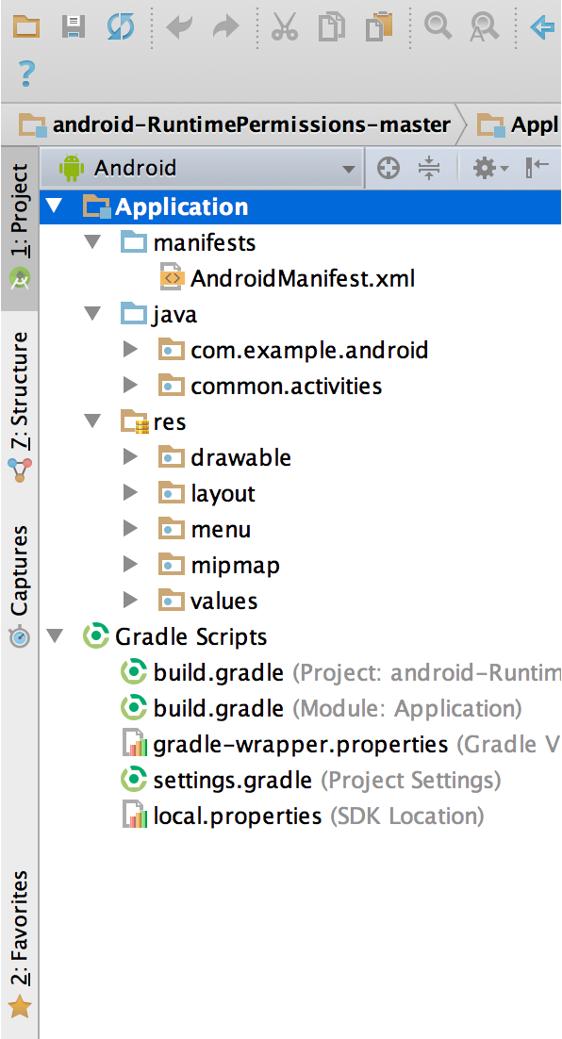

**Figure 1:** The project files in Android view.

The Android project structure on disk differs from this flattened representation. To see the actual file structure of the project, select **Project** from the **Project** dropdown (in figure 1, it's showing as **Android**).

You can also customize the view of the project files to focus on specific aspects of your app development. For example, selecting the **Problems** view of your project displays links to the source files containing any recognized coding and syntax errors, such as a missing XML element closing tag in a layout file.

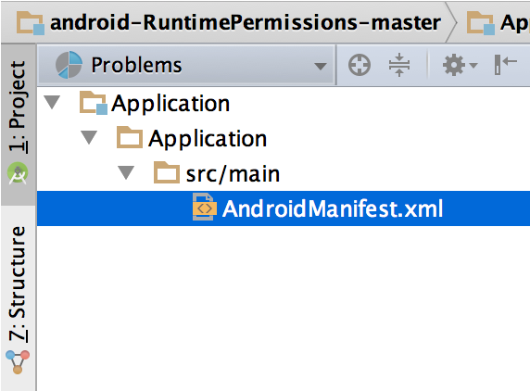

**Figure 2:** The project files in Problems view, showing a layout file with a problem.

***The User Interface :***

The Android Studio main window is made up of several logical areas identified in figure 3.

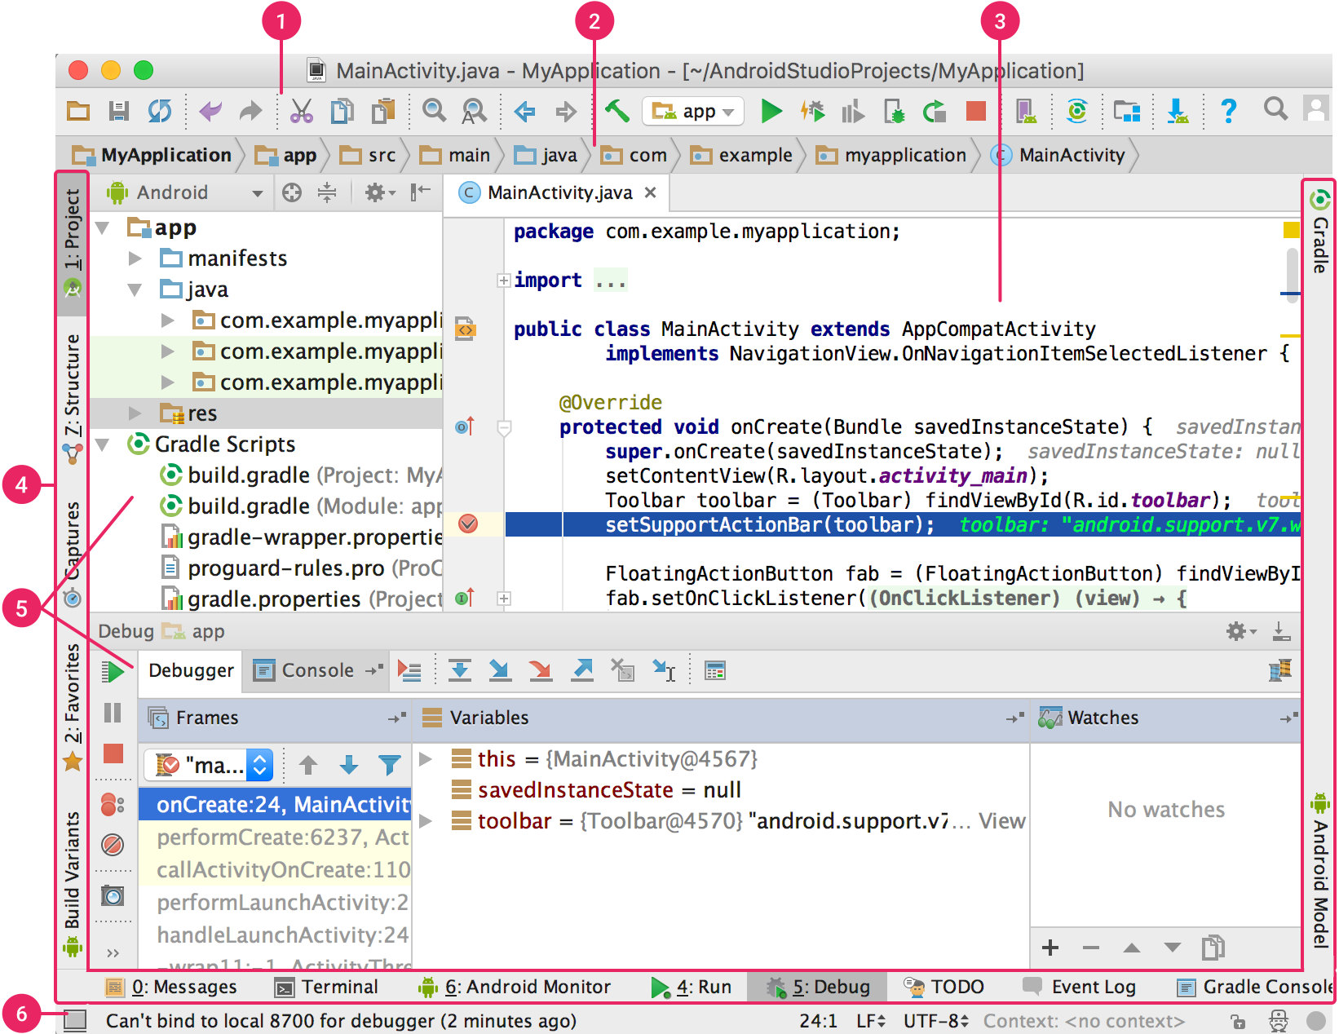

**Figure 3:** The Android Studio main window.

1. The toolbar lets you carry out a wide range of actions, including running your app and launching Android tools.
2. The navigation bar helps you navigate through your project and open files for editing. It provides a more compact view of the structure visible in the Project window.
3. The editor window is where you create and modify code. Depending on the current file type, the editor can change. For example, when viewing a layout file, the editor displays the Layout Editor.
4. The tool window bar runs around the outside of the IDE window and contains the buttons that allow you to expand or collapse individual tool windows.
5. The tool windows give you access to specific tasks like project management, search, version control, and more. You can expand them and collapse them.
6. The status bar displays the status of your project and the IDE itself, as well as any warnings or messages.

***Tool Windows :***

Instead of using preset perspectives, Android Studio follows your context and automatically brings up relevant tool windows as you work. By default, the most commonly used tool windows are pinned to the tool window bar at the edges of the application window.

* To expand or collapse a tool window, click the tool’s name in the tool window bar. You can also drag, pin, unpin, attach, and detach tool windows.
* To return to the current default tool window layout, click **Window > Restore Default Layout** or customize your default layout by clicking **Window > Store Current Layout as Default.**
* To show or hide the entire tool window bar, click the window  icon in the bottom left-hand corner of the Android Studio window.
* To locate a specific tool window, hover over the window icon and select the tool window from the menu.

You can also use keyboard shortcuts to open tool windows. Figure 4 shows the shortcuts for the most common windows.

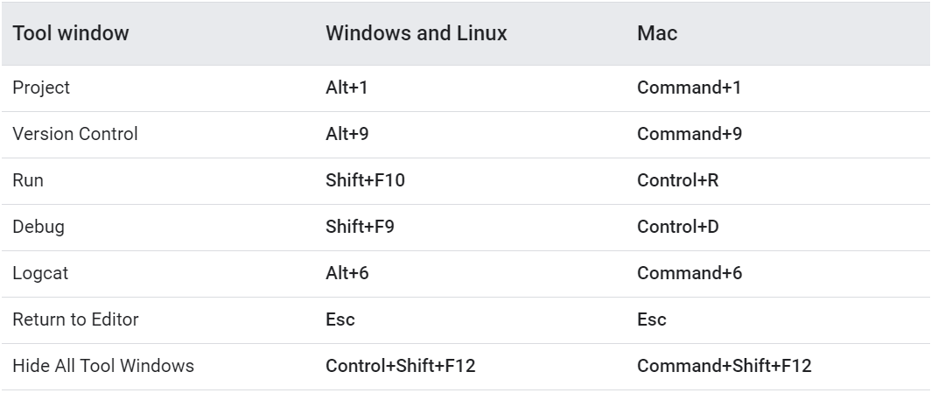

**Figure 4:** Keyboard shortcuts for some useful tool windows.

If you want to hide all toolbars, tool windows, and editor tabs, click **View > Enter Distraction Free Mode.** This enables *Distraction Free Mode.* To exit Distraction Free Mode, click **View > Exit Distraction Free Mode.**

***Gradle Build System :***

Android Studio uses Gradle as the foundation of the build system, with more Android-specific capabilities provided by the Android plugin for Gradle. This build system runs as an integrated tool from the Android Studio menu, and independently from the command line. You can use the features of the build system to do the following:

* Customize, configure, and extend the build process.
* Create multiple APKs for your app, with different features using the same project and modules.
* Reuse code and resources across sourcesets.